School of Computer Science and Artificial Intelligence

 | LabAssignment-9.5
Program | :B.Tech(CSE AIML)
Course Title | :AI Assisted Coding
Course Code | : 23CS002PC304
Semester | : VI
AcademicSession :2025-2026
Name of Student : M .sriram
Enrollment No. : 2303A52165
Batch No. | : 34
DATE: 13-2-26
Problem 1: String Utilities Function
Given code: def reverse_string(text):
return text[::-1]

prompt:
Generate documentation for the given Python function.
Include:
- A simple docstring
- Inline comments
- Google-style documentation
Also explain which documentation style is best for a string utility library and why.

Task:
1.Inline Comments:
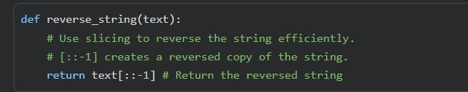

- Docstring Documentation:
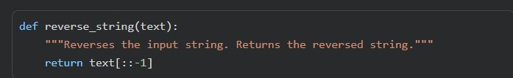

- Google-style Documentation:
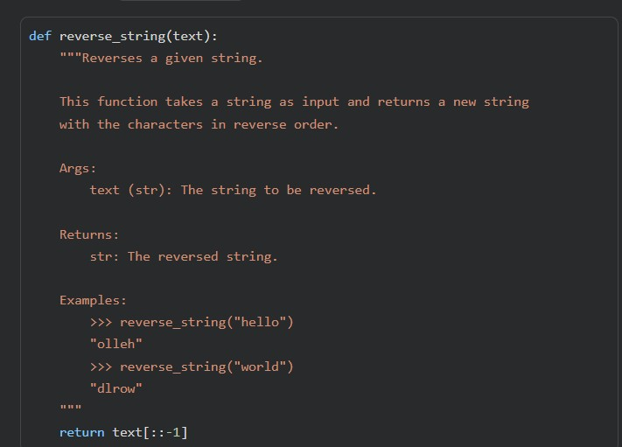

2.Compare the three documentation styles.
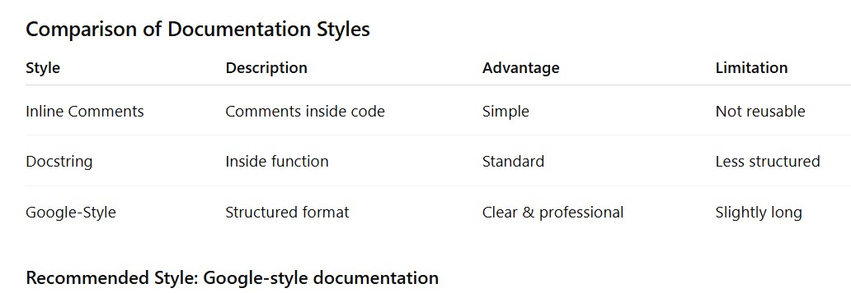

3. Recommend the most suitable style for a utility-based string library.

API Clarity and Completeness:
A library is designed to be used by other developers. Google-style docstrings clearly define the function's contract: what parameters it expects, their types, what it returns, its type, and any potential side effects or exceptions. This is crucial for library users to understand and correctly integrate your functions without needing to read the source code.

Automated Documentation Generation: Tools like Sphinx (with the numpydoc or sphinx.ext.napoleon extensions) can parse Google-style docstrings to automatically generate professional, navigable API documentation websites. This significantly reduces the manual effort of maintaining separate documentation and ensures it stays synchronized with the code.

Consistency: Adopting a structured style like Google-style enforces consistency across the entire library. This makes it easier for contributors to understand existing code and write new code that conforms to the same documentation standards.

Examples for Easy Adoption:
Google-style often includes example usage within the docstring. For a utility library, concrete examples of how to use each function are invaluable for quick understanding and adoption by users
.
Maintainability:
While initially more verbose, the structured nature makes it easier to review, update, and ensure completeness of the documentation as the library evolves. It prevents critical information from being missed.

Problem 2: Password Strength Checker: Given code: def check_strength(password):
return len(password) >= 8

prompt:
First compare documentation styles for security-related code.
Then generate:
- Inline comments
- Docstring
- Google-style documentation

Finally recommend the best documentation style.

Function:
def check_strength(password): return len(password) >= 8

Task:
1.Inline Comments:
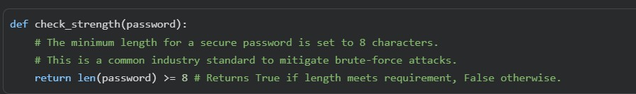

2. Docstring Documentation:
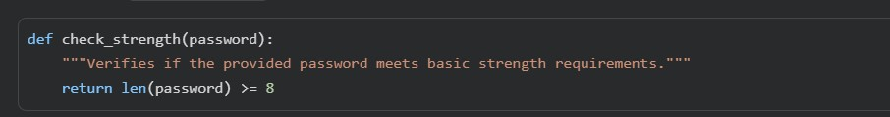

3.Google-style Documentation:
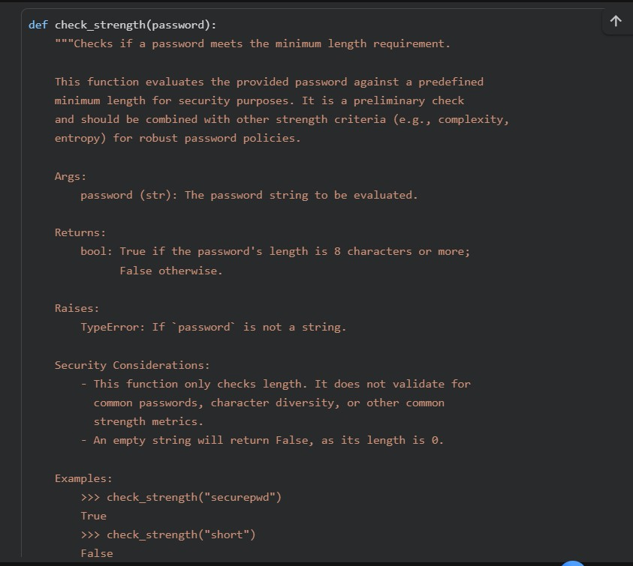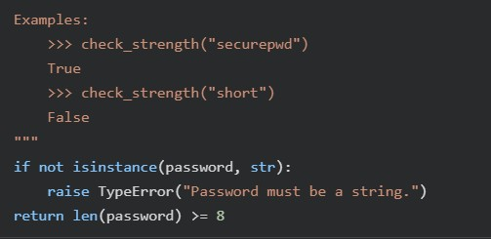

- Compare documentation styles for security-related code.
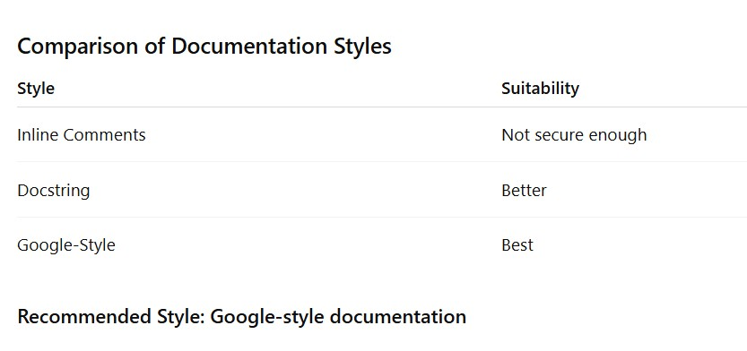
- Recommend the most appropriate style.

For Google-style documentation (or a similar comprehensive, structured style like reStructuredText or NumPy style) is the unequivocally best choice.

Precision and Unambiguity:
Security functions demand absolute clarity. Google-style docstrings force developers to explicitly define every aspect: what input password means (e.g., cleartext, hashed?), its type, the exact criteria (e.g., 'length >= 8'),

Auditability and Review:
Comprehensive documentation makes it significantly easier for security auditors, penetration testers, and peer reviewers to understand the function's security posture, identify potential flaws, and verify compliance with security requirements.

Clear API Contract:
For functions dealing with sensitive data or operations, the documentation is the contract. Google-style clearly outlines how to interact with the function securely and what security guarantees (or lack thereof) it provides. Handling Edge Cases and Errors: Security bugs often stem from mishandling unexpected inputs. Structured docstrings encourage documenting how edge cases, invalid inputs, or exceptional conditions are managed, which is crucial for robust security.

Automated Documentation Generation:
Tools can parse these structured docstrings to generate comprehensive security documentation, ensuring that the critical security information is consistently available and easily navigable.

Problem 3: Math Utilities Module:
Prompt :
Create a Python module math_utils.py.
Add functions:
- square(n)
- cube(n)
- factorial(n)

Include Google-style documentation.
Explain how to generate HTML documentation.

Task:
1. Create a module math_utils.py with functions: o square(n) o cube(n) o factorial(n)
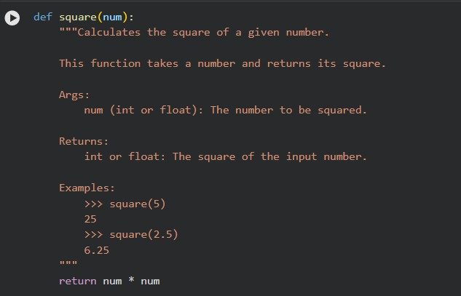
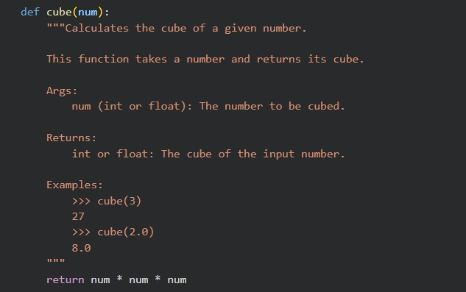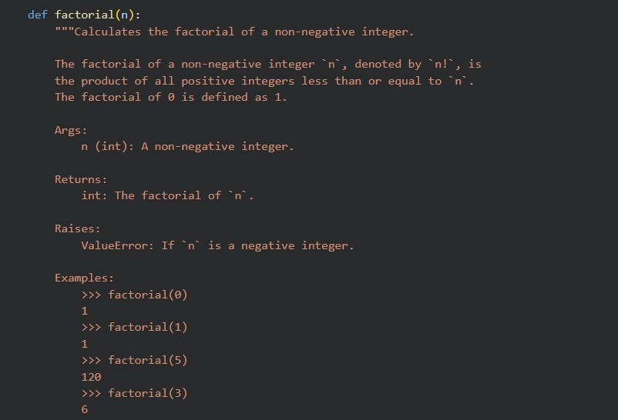

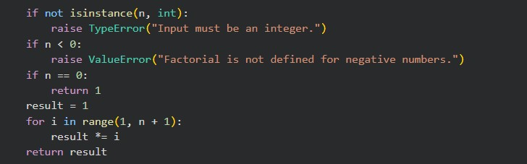

2.Generate docstrings automatically using AI tools.

Contextual Understanding:
AI models are trained on vast amounts of code and corresponding documentation. They learn patterns in how functions, classes, and methods are typically documented.

Input Analysis:
When you feed your code to an AI docstring generator, it analyzes the function signature (name, parameters, return types), comments within the function, and sometimes even the logic inside the function body.

Docstring Suggestion:
Based on this analysis and its training, the AI suggests a docstring that summarizes the function's purpose, describes its arguments, return values, and sometimes even provides examples or raises sections.

Common Approaches and Tools:

IDE Extensions: Many popular Integrated Development Environments (IDEs) like VS Code, PyCharm, or even Jupyter environments (through specific extensions) offer AI-powered docstring generation. Examples include extensions that integrate with services like GitHub Copilot or dedicated docstring generators.

Dedicated AI Services/Libraries:
There are also standalone tools or Python libraries that focus specifically on docstring generation, often integrating with large language models.
Example of AI-Generated Docstring for square(num).
3. Export documentation as an HTML file.
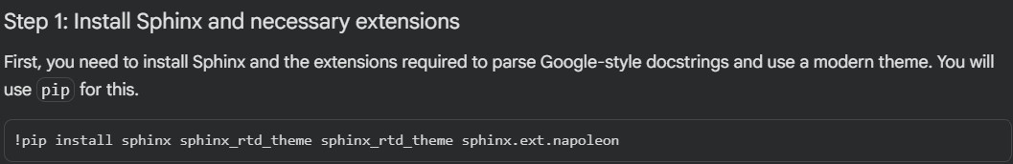

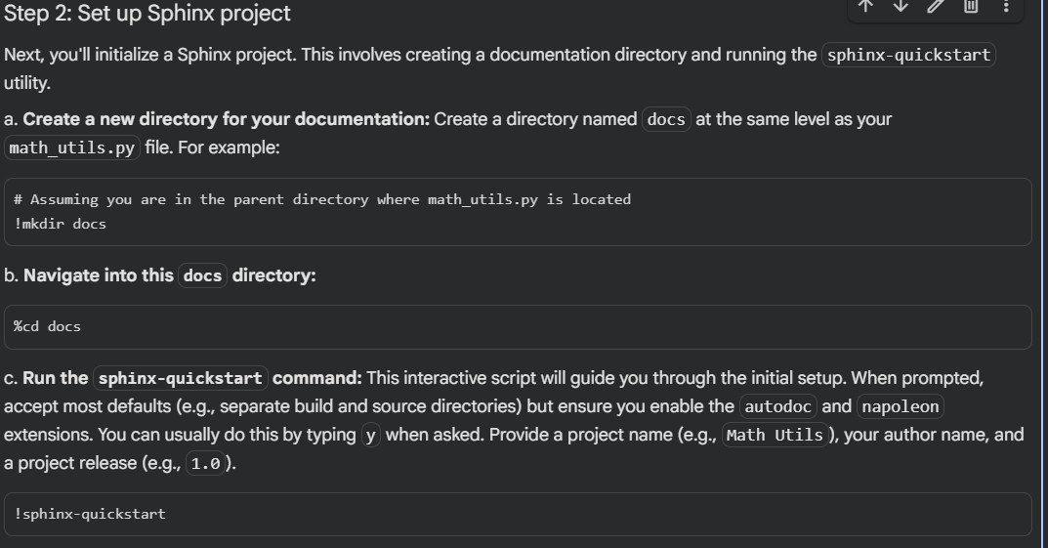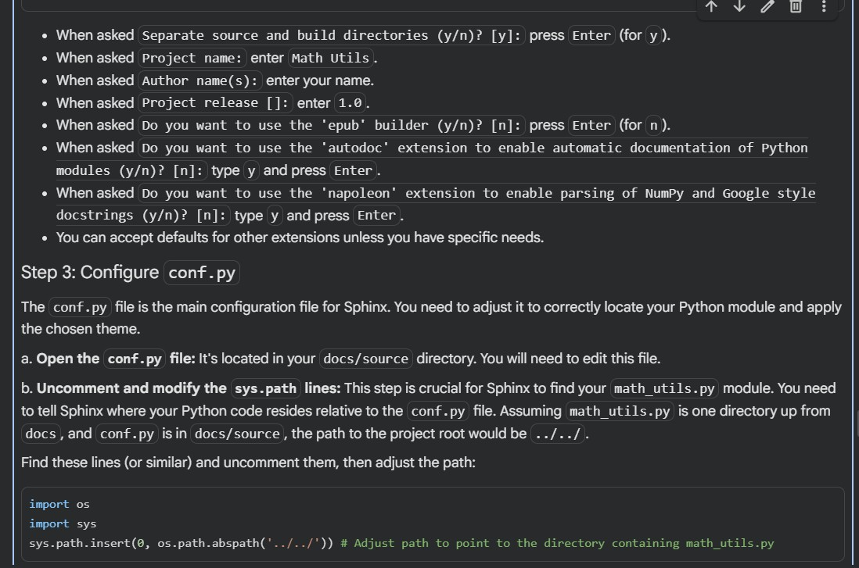

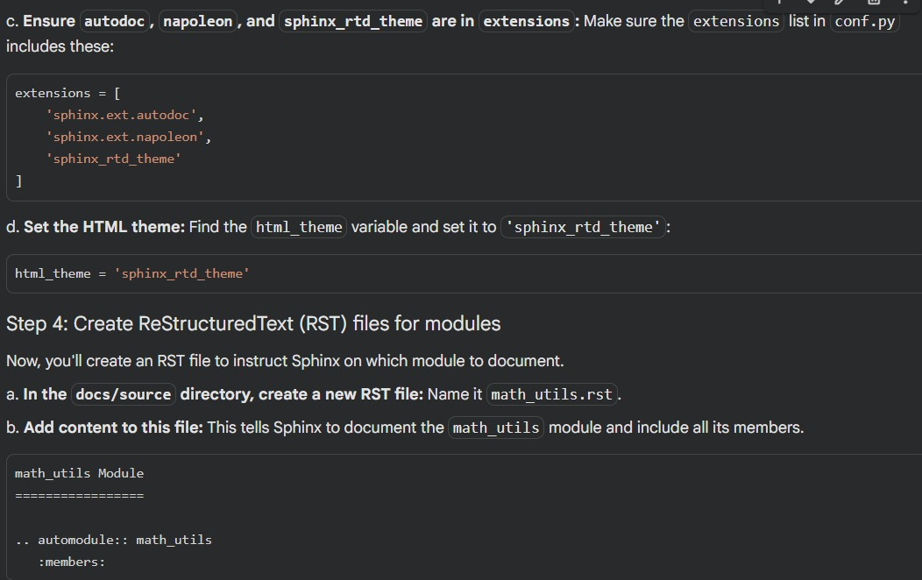

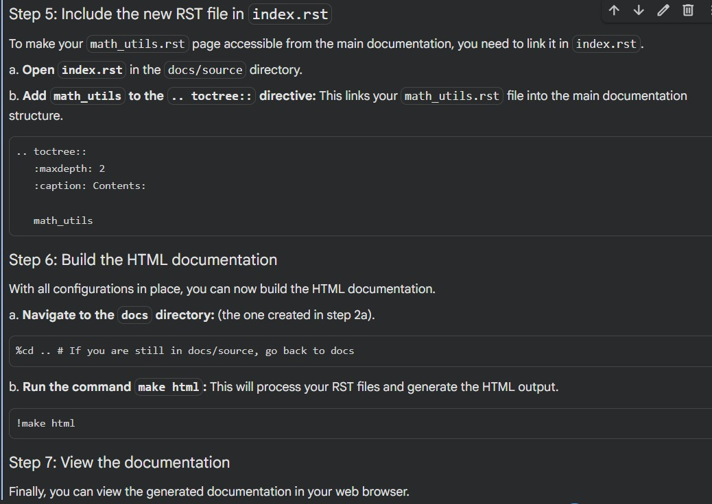

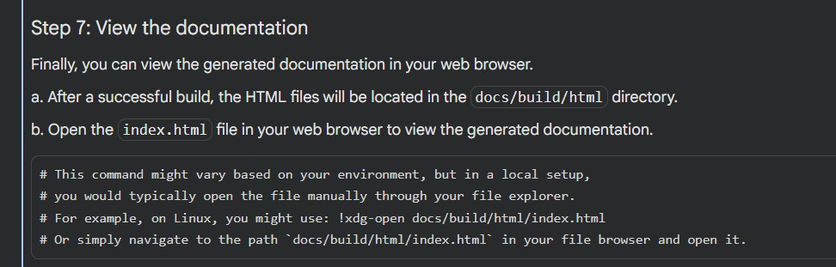

Problem 4: Attendance Management Module

Prompt:
Create attendance.py with:
- mark_present(student)
- mark_absent(student)
- get_attendance(student)

Add docstrings and explain documentation viewing

Task:
1. Create a module attendance.py with functions:
-mark_present(student)
- mark_absent(student)
- get_attendance(student)
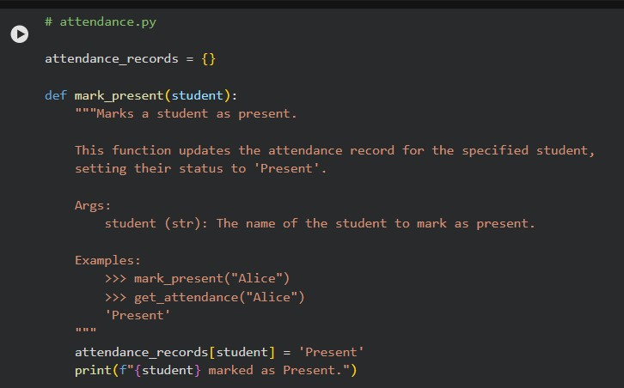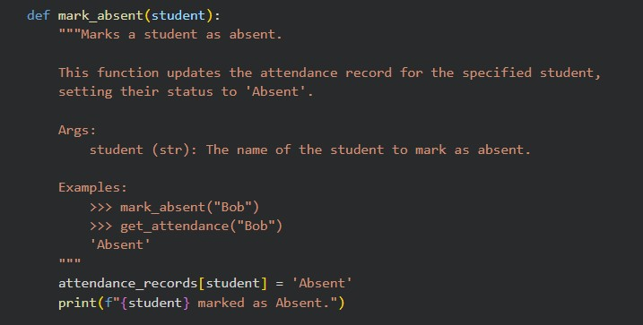
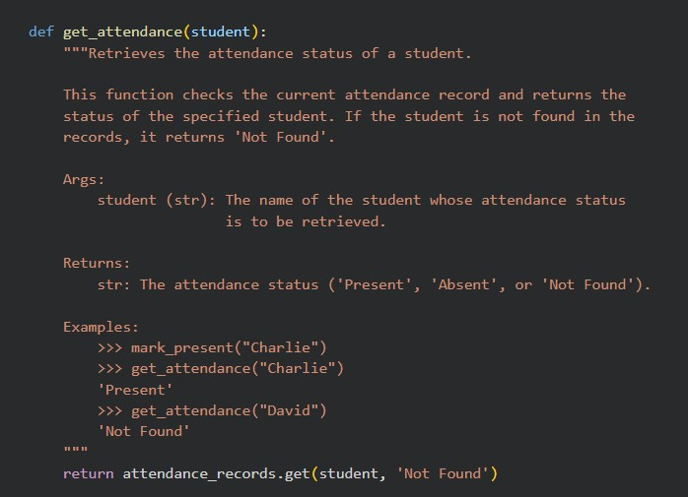
- Add proper docstrings.
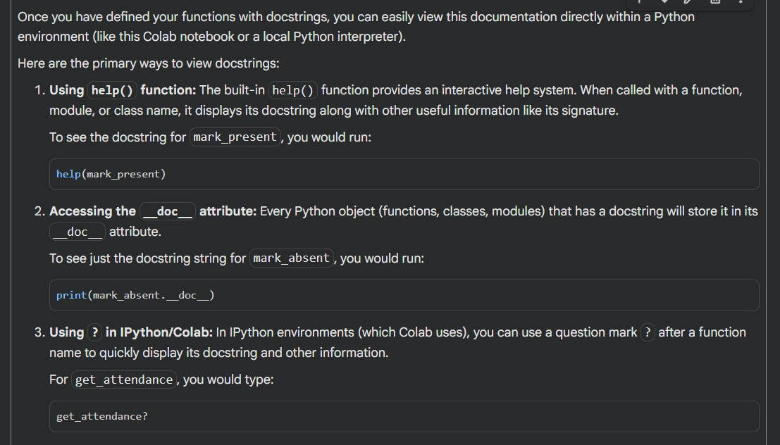

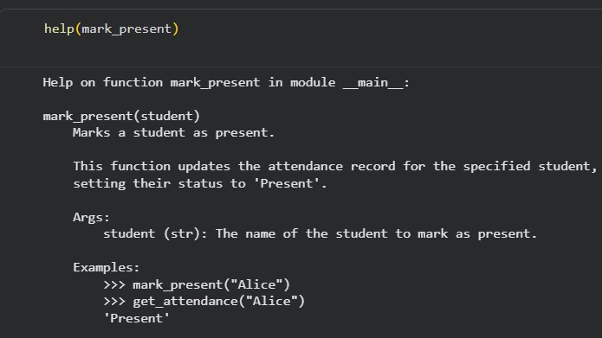

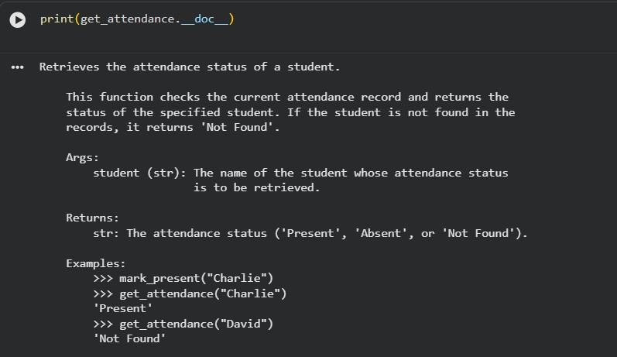

- Generate and view documentation in terminal and browse
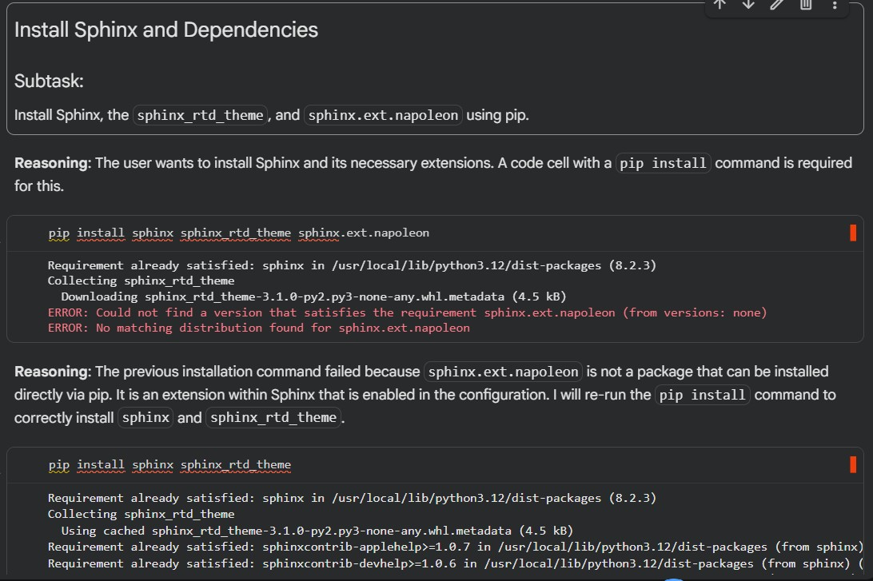

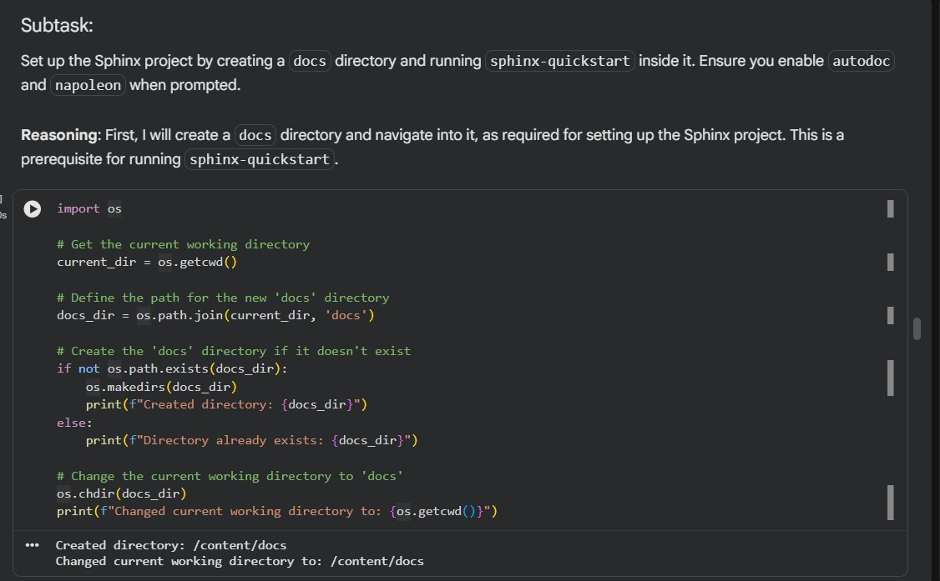

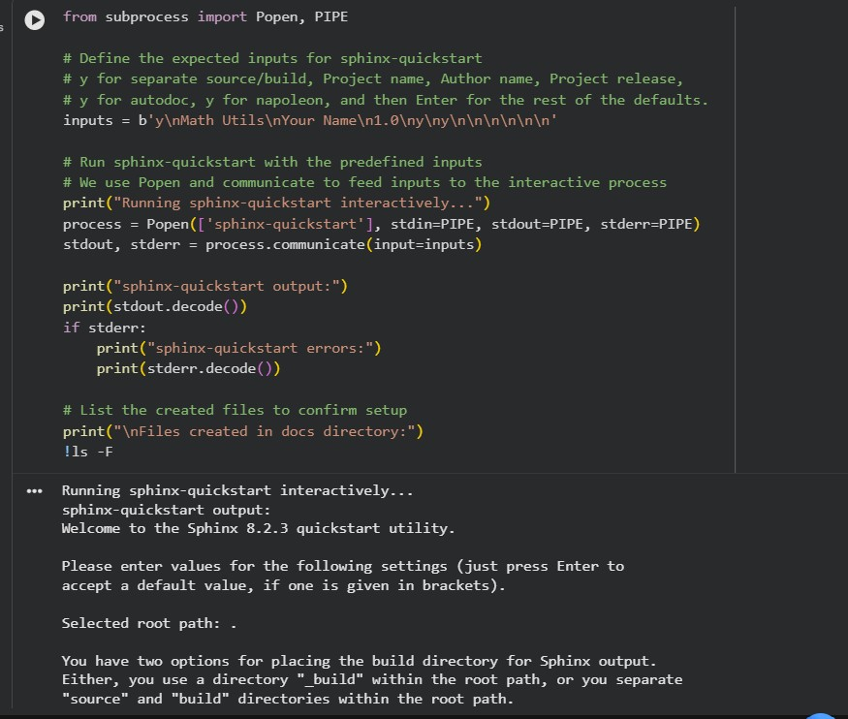

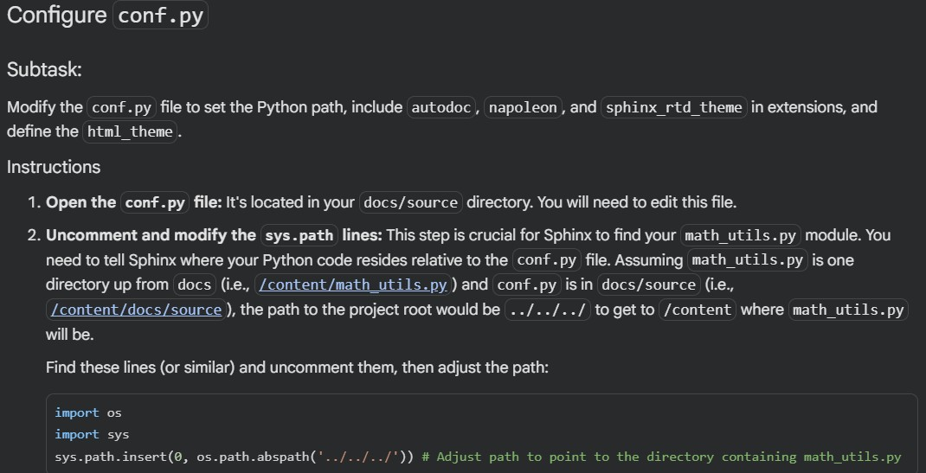
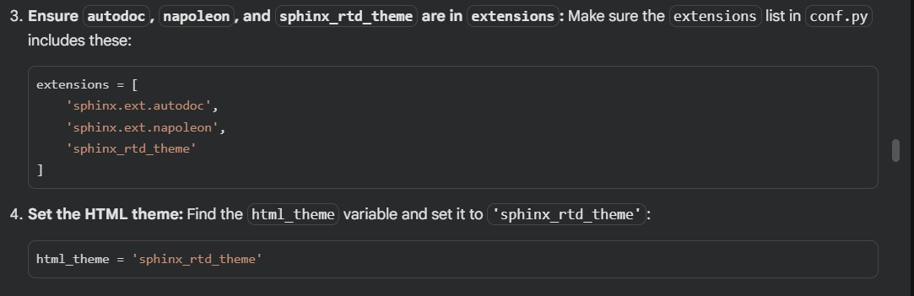

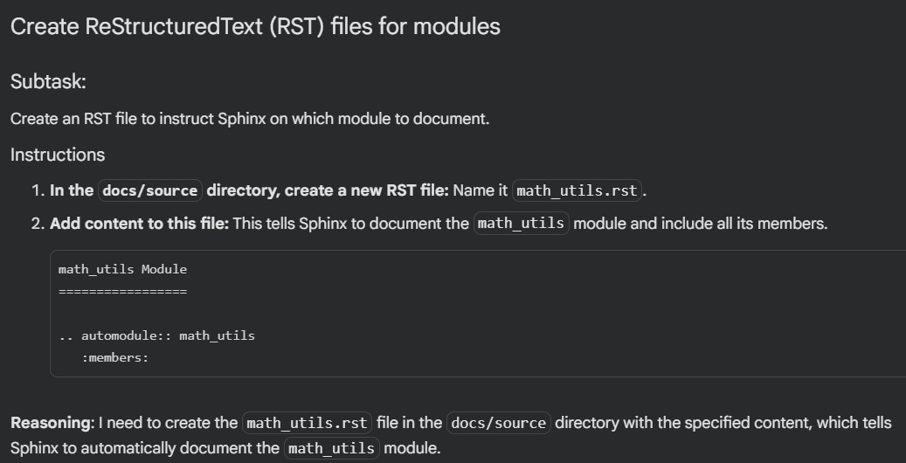

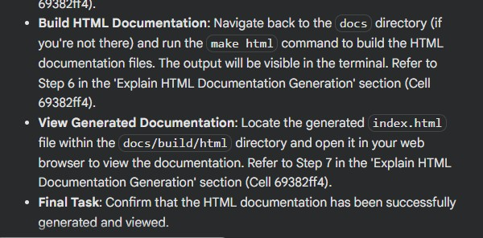

Problem 5: File Handling Function:

Given Code: def read_file(filename): with open(filename, 'r') as f:
return f.read()

Prompt:
First compare documentation styles for file handling and exception handling. Then generate:
- Inline comments
- Docstring
- Google-style documentation

Recommend the best style.

Task:
Write documentation using all three formats.
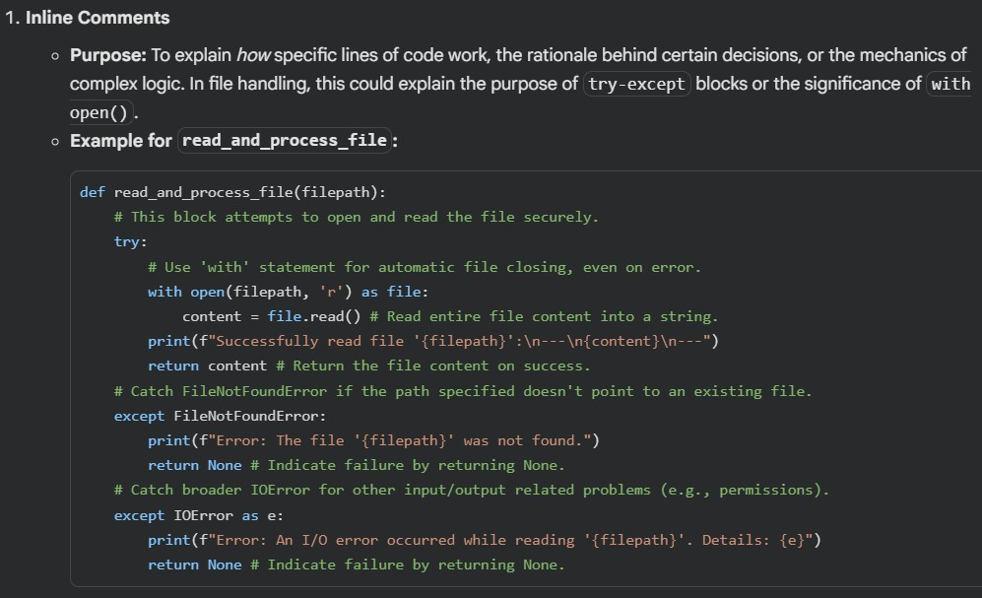

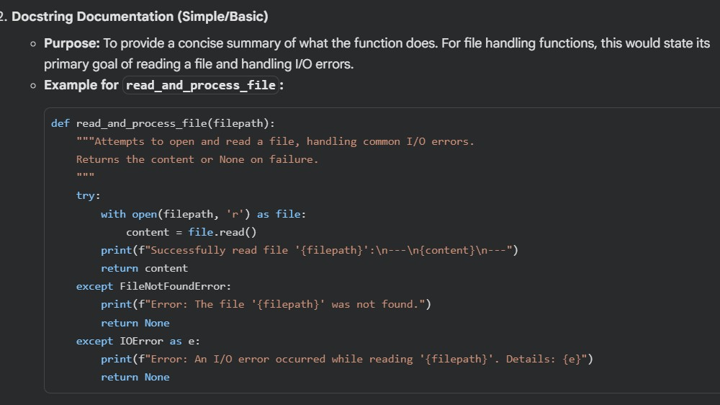

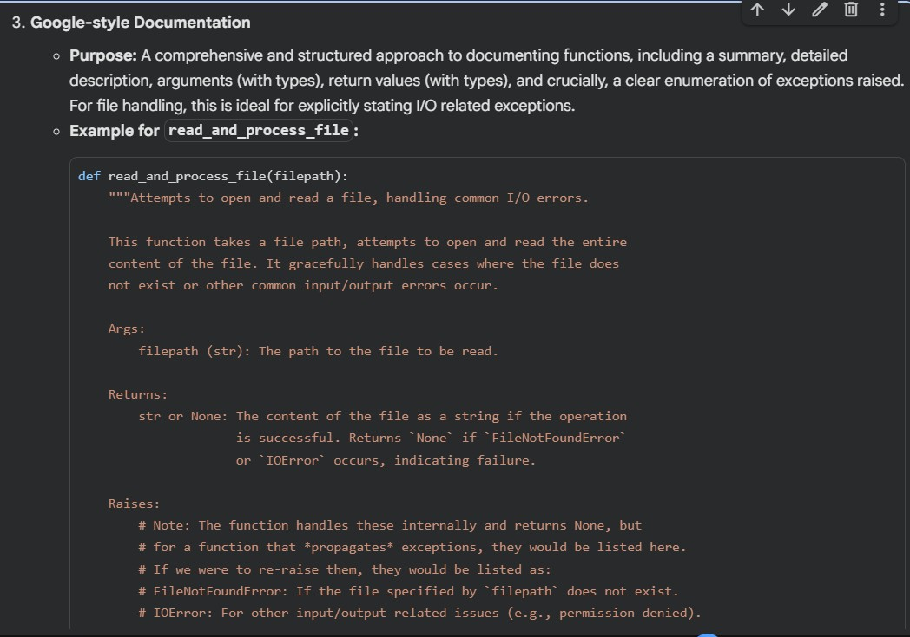

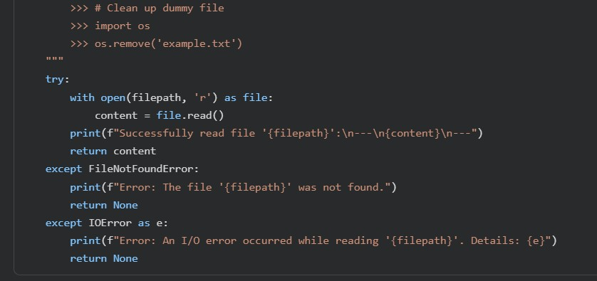

- Identify which style best explains exception handling.
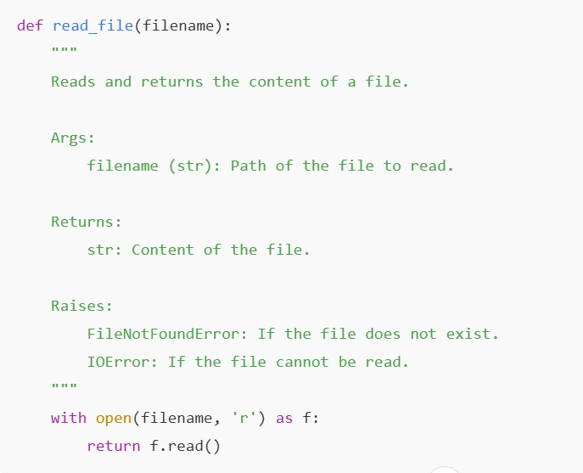

- Justify your recommendation.

